**exercise time**

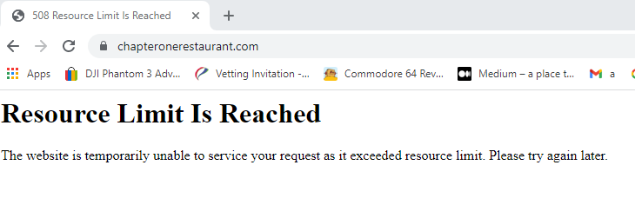

**Watch video then complete exercises ….**

<https://youtu.be/NQP89ish9t8> create a new responsive site …

**Questions after video**

Explain what the main. css does ?_____________

Explain what the javascript code does ?___________________-

Explain a TLD

Explain a sub domain

Explain dns records

**You now have to do the following…**

Modify the 6 videos to play the social engineering videos…

Change the font size to 15

Modify the background color to light blue….

Change the circle to be green

Modify text in title to say ……. your name …….

Modify main text in page to say ……. your name …….

**Create a twitter account for dontgetscammed (1)**

**Create a insta account for dontgetscammed (2)**

**Create a facebook account for dontgetscammed (3)**

**Create a youtube account for dontgetscammed**

**Create a ticktok account for dontgetscammed**

**Create gmail emails account for dontgetscammed**

**Create a new logo?**

Try Create a new favicon.ico <https://youtu.be/s9QO0pTzZ-w> in photoshop

Crete a github account

Get a Cost for new site dontgetscammed.com

**Sample site to modify**

<https://drive.google.com/file/d/1Zr80JIe30eJEUIx_8o1inyHHru18T4mQ/view>

Test the site ….on 3 devices

⭐️ Course Contents ⭐️ ⌨️ ([00:00](https://www.youtube.com/watch?v=NQP89ish9t8&t=0s)) Introduction ⌨️ ([00:34](https://www.youtube.com/watch?v=NQP89ish9t8&t=34s)) Creating a website ⌨️ ([38:41](https://www.youtube.com/watch?v=NQP89ish9t8&t=2321s)) Getting a custom URL ⌨️ ([42:45](https://www.youtube.com/watch?v=NQP89ish9t8&t=2565s)) Getting web hosting ⌨️ ([48:25](https://www.youtube.com/watch?v=NQP89ish9t8&t=2905s)) Creating a custom email address ⌨️ ([48:25](https://www.youtube.com/watch?v=NQP89ish9t8&t=2905s)) Updating Nameservers ⌨️ ([51:35](https://www.youtube.com/watch?v=NQP89ish9t8&t=3095s)) Hosting for free with GitHub Pages ⌨️ ([56:08](https://www.youtube.com/watch?v=NQP89ish9t8&t=3368s)) Updating DNS Settings ⌨️ ([59:15](https://www.youtube.com/watch?v=NQP89ish9t8&t=3555s)) Conclusion